Test Case: tc001_SPX_Dev5_Crear_Nueva_Linea_Requisicion_Spot_Tipo_Cobro_CC
Step 1 - Enter username and password and click to button Enter : Credentials Entered
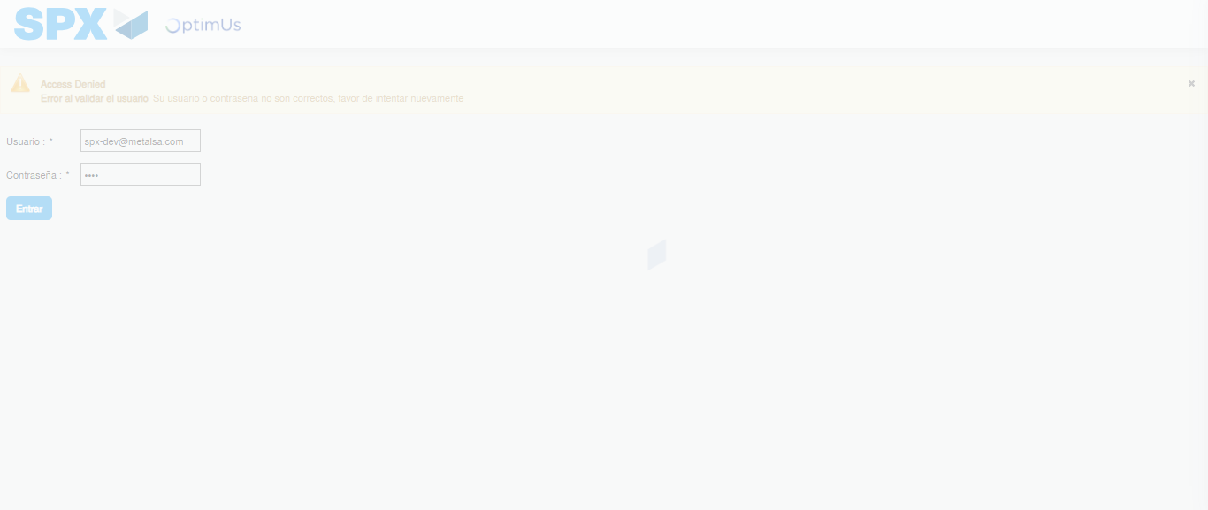Image file-name: QC_Testing-tc001_SPX_Dev5_Crear_Nueva_Linea_Requisicion_Spot_Tipo_Cobro_CC-1790174961336

Step 2 - Select to UEN and Access to Spot Buy Requisitions : UEN Correctly selected and Correct access
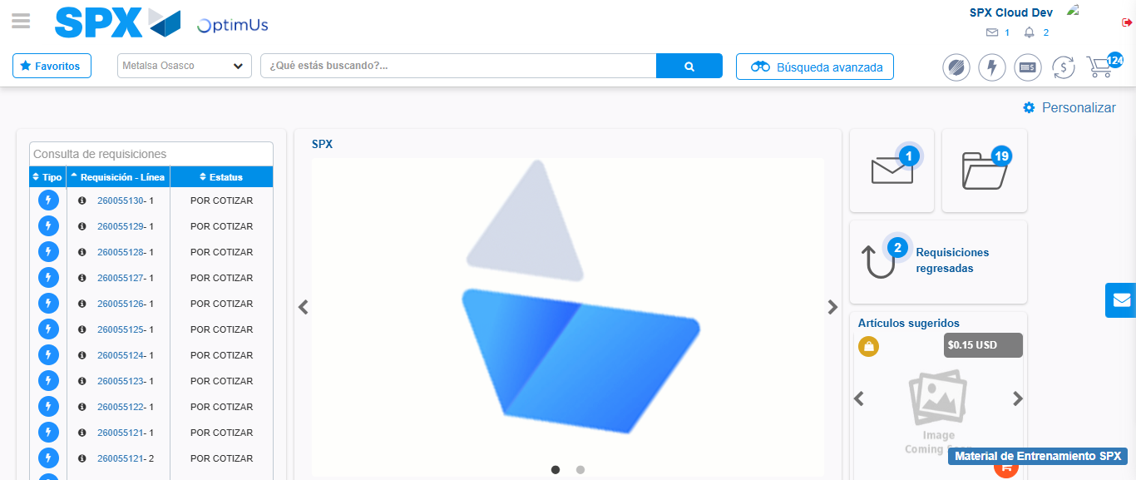Image file-name: QC_Testing-tc001_SPX_Dev5_Crear_Nueva_Linea_Requisicion_Spot_Tipo_Cobro_CC-1790174984922

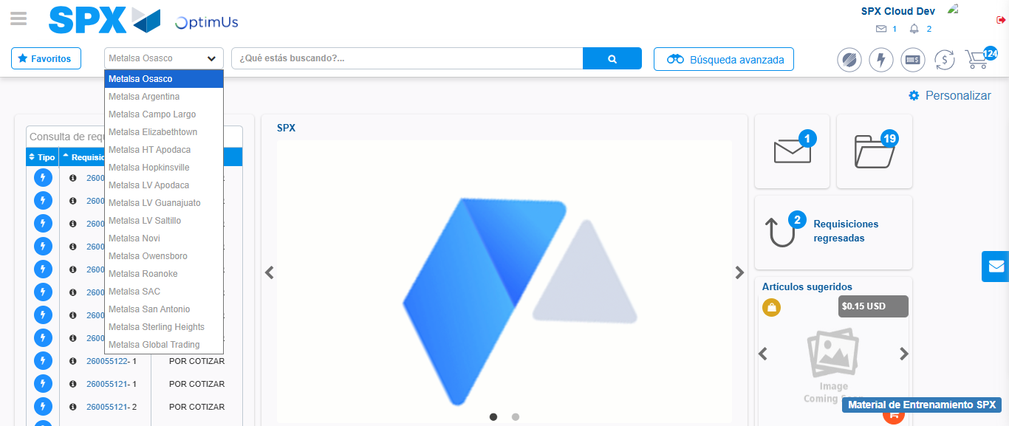Image file-name: QC_Testing-tc001_SPX_Dev5_Crear_Nueva_Linea_Requisicion_Spot_Tipo_Cobro_CC-1790174985634

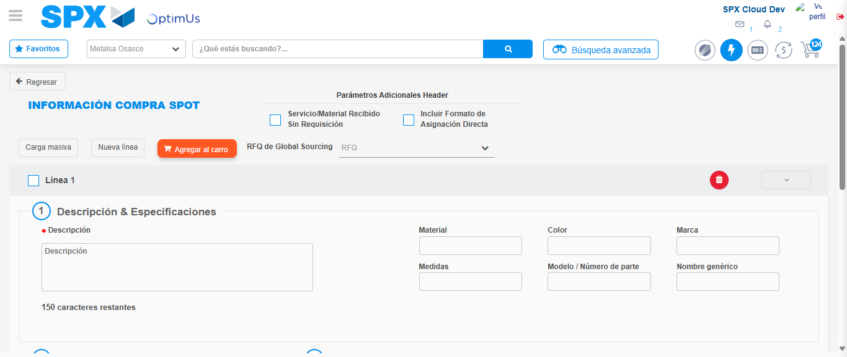Image file-name: QC_Testing-tc001_SPX_Dev5_Crear_Nueva_Linea_Requisicion_Spot_Tipo_Cobro_CC-1790175005185

Step 3 - Data Capture Spot Buy Requisition: Data captured correctly
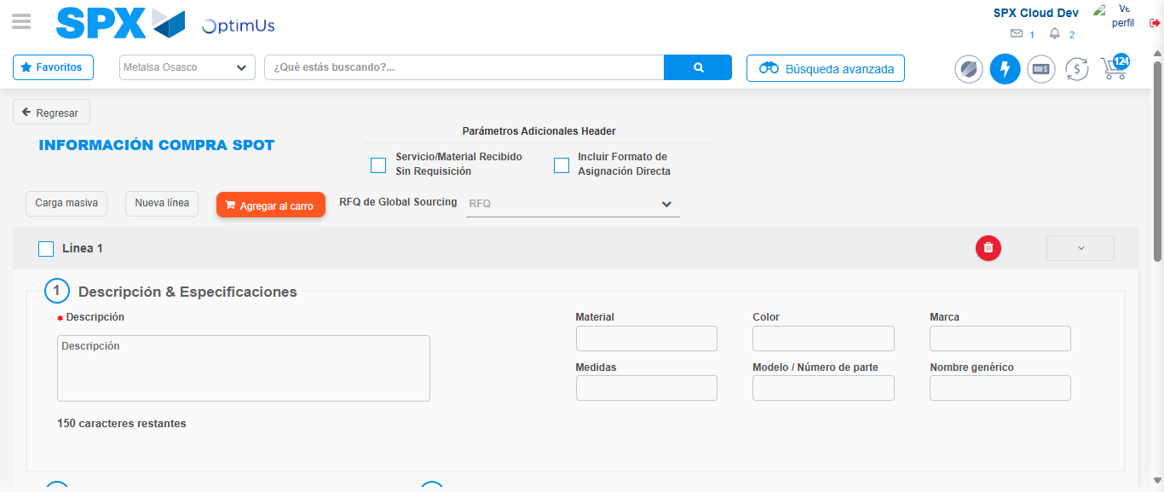Image file-name: QC_Testing-tc001_SPX_Dev5_Crear_Nueva_Linea_Requisicion_Spot_Tipo_Cobro_CC-1790175005479

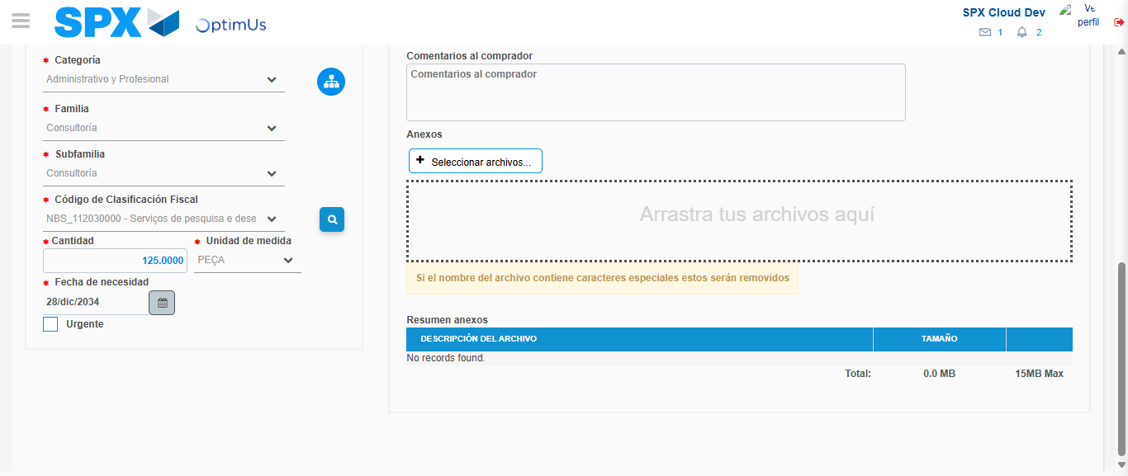Image file-name: QC_Testing-tc001_SPX_Dev5_Crear_Nueva_Linea_Requisicion_Spot_Tipo_Cobro_CC-1790175021474

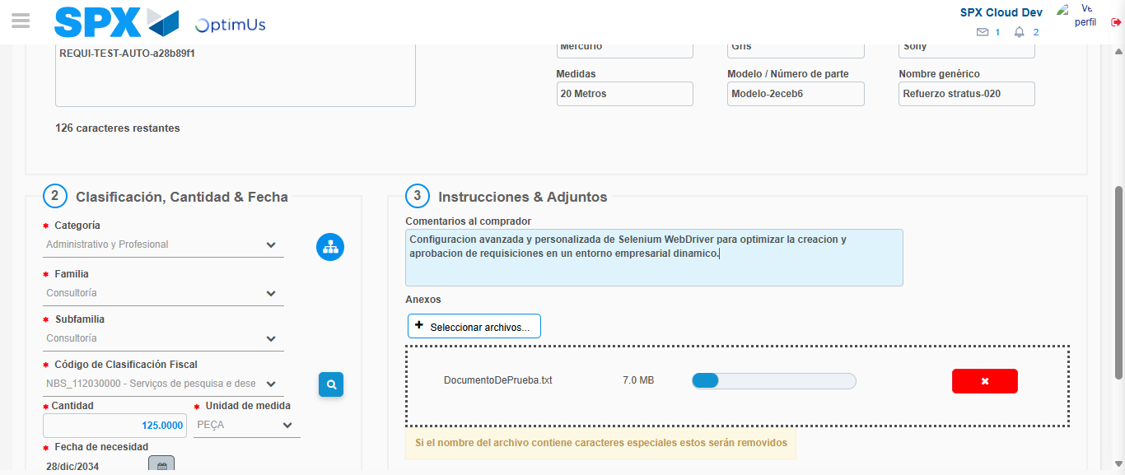Image file-name: QC_Testing-tc001_SPX_Dev5_Crear_Nueva_Linea_Requisicion_Spot_Tipo_Cobro_CC-1790175022234

Step 4 - Add new line and data capture second line: Line add correctly
Image file-name: QC_Testing-tc001_SPX_Dev5_Crear_Nueva_Linea_Requisicion_Spot_Tipo_Cobro_CC-1790175005479

Image file-name: QC_Testing-tc001_SPX_Dev5_Crear_Nueva_Linea_Requisicion_Spot_Tipo_Cobro_CC-1790175021474

Image file-name: QC_Testing-tc001_SPX_Dev5_Crear_Nueva_Linea_Requisicion_Spot_Tipo_Cobro_CC-1790175022234

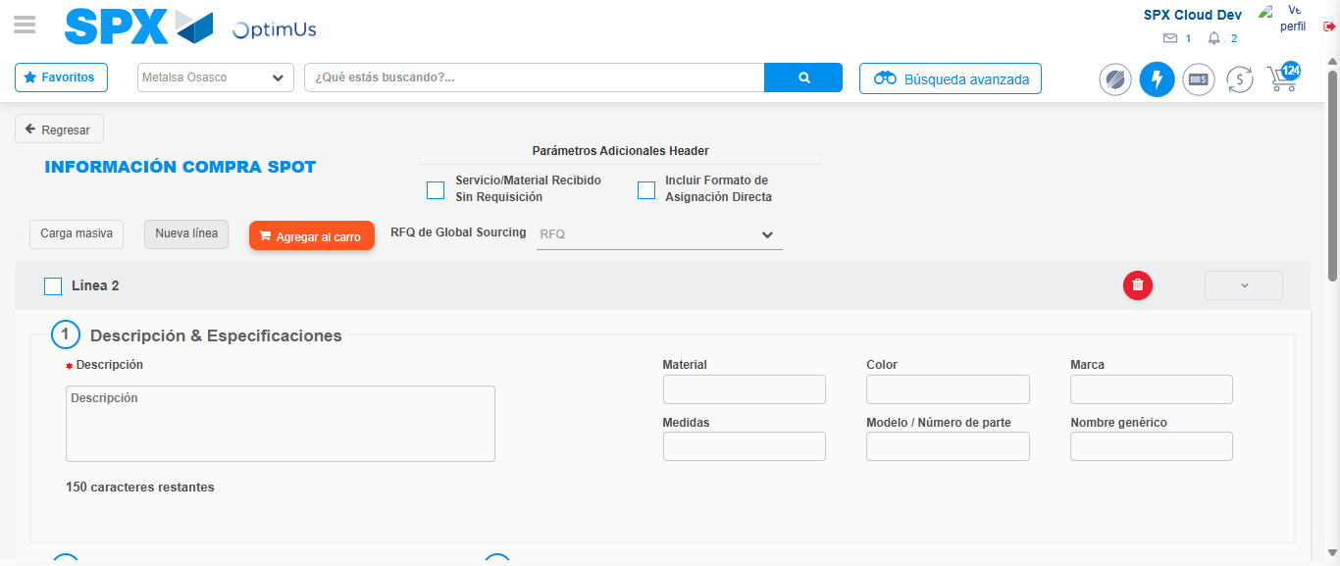Image file-name: QC_Testing-tc001_SPX_Dev5_Crear_Nueva_Linea_Requisicion_Spot_Tipo_Cobro_CC-1790175024516

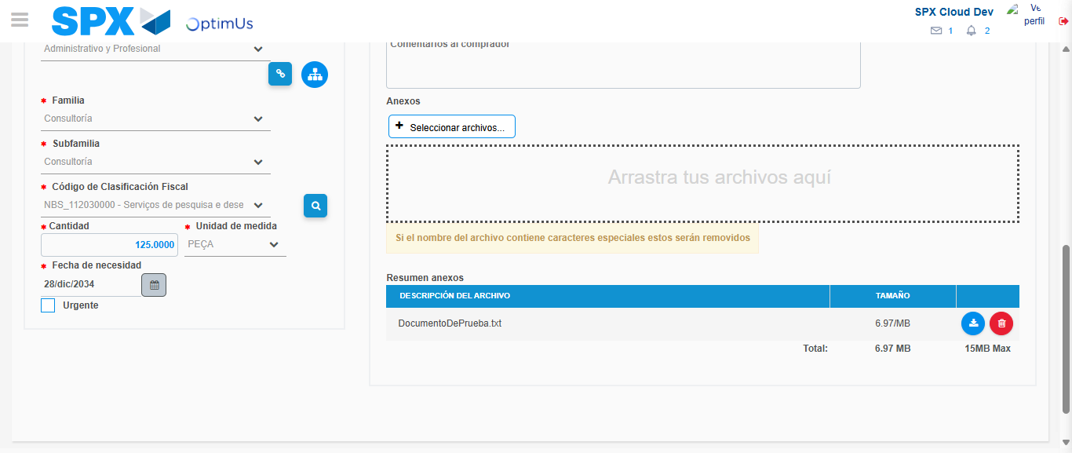Image file-name: QC_Testing-tc001_SPX_Dev5_Crear_Nueva_Linea_Requisicion_Spot_Tipo_Cobro_CC-1790175041786

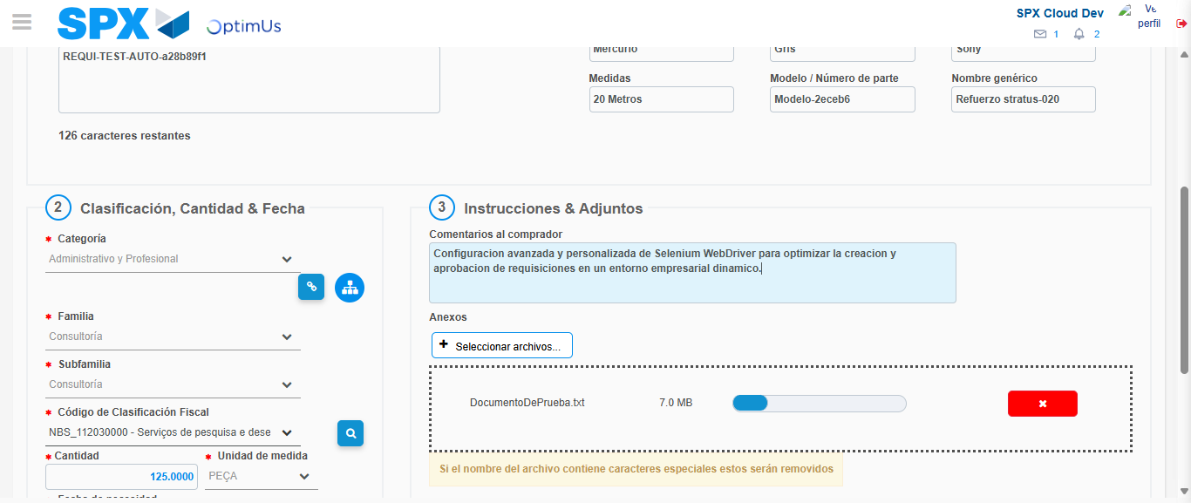Image file-name: QC_Testing-tc001_SPX_Dev5_Crear_Nueva_Linea_Requisicion_Spot_Tipo_Cobro_CC-1790175042579

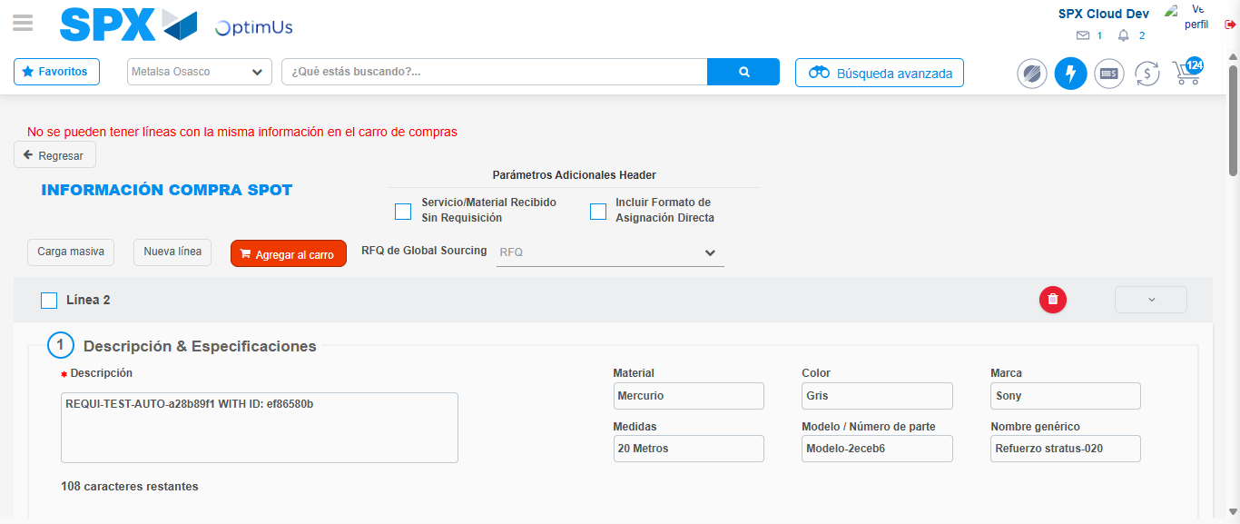Image file-name: QC_Testing-tc001_SPX_Dev5_Crear_Nueva_Linea_Requisicion_Spot_Tipo_Cobro_CC-1790175046946

Step 8 - Return to Main Page SPX : Return to Main Page SPX
Image file-name: QC_Testing-tc001_SPX_Dev5_Crear_Nueva_Linea_Requisicion_Spot_Tipo_Cobro_CC-1790174984922

Image file-name: QC_Testing-tc001_SPX_Dev5_Crear_Nueva_Linea_Requisicion_Spot_Tipo_Cobro_CC-1790174985634

Image file-name: QC_Testing-tc001_SPX_Dev5_Crear_Nueva_Linea_Requisicion_Spot_Tipo_Cobro_CC-1790175005185

Image file-name: QC_Testing-tc001_SPX_Dev5_Crear_Nueva_Linea_Requisicion_Spot_Tipo_Cobro_CC-1790175049160

Image file-name: QC_Testing-tc001_SPX_Dev5_Crear_Nueva_Linea_Requisicion_Spot_Tipo_Cobro_CC-1790175049323

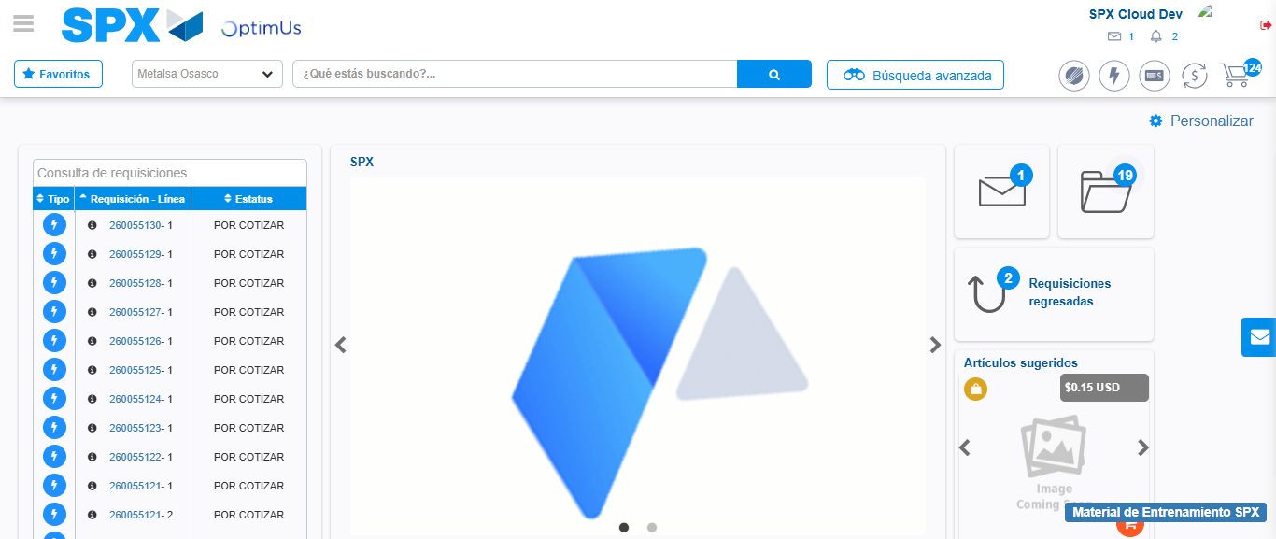Image file-name: QC_Testing-tc001_SPX_Dev5_Crear_Nueva_Linea_Requisicion_Spot_Tipo_Cobro_CC-1790175070523

Step 9 - Log Out : Log Out SPX
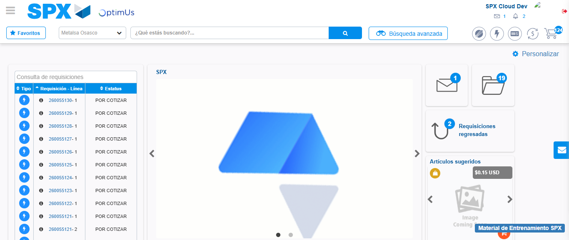Image file-name: QC_Testing-tc001_SPX_Dev5_Crear_Nueva_Linea_Requisicion_Spot_Tipo_Cobro_CC-1790175070921

